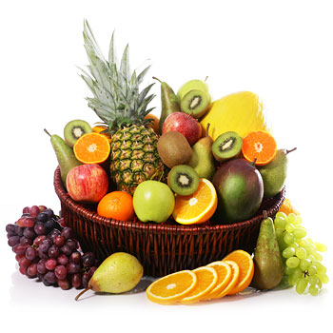
Fruit Brochure

Description:

A creative brochure that supplies facts and information about a type of fruit. The brochure will include both written and pictorial information displayed in a brochure with eight sections – four on the front and four on the back. The brochure will fold up like a travel pamphlet or map.

Steps:

- Choosing a topic:
Each student will be given a different type of fruit to research so there will be no duplicates.

- Research:
Students will have two classes to research the topic.

- Each brochure must include:

  - History: where the fruit was developed or originally grown
  - Geography: climate and locations where the fruit is mainly grown
  - Fruit facts: classification, how it is grown, importing/exporting
  - Pests and disease
  - Uses
  - Buying and storage
  - Recipe or interesting way to serve fruit
  - Title page

- Putting the brochure together:

  - Use the provided paper and fold into four equal parts.
  - Design a title page. It must include the name of the fruit, a coloured drawing of the fruit and a background. This will be the first ‘page’.
  - Make headings for each research topic area. Information must be neatly written, printed or done on a computer and pasted to the remaining seven panels securely in the order given

